Nease High School
AP 2D Art and Design
AP Drawing

WHAT YOU NEED TO DO:
In order to complete 15 works by the end of April, 2024, you will need to complete THREE projects
over the summer. These must be NEW works created over the summer from the list below. They cannot be works from the past school year.

Summer work is due the first day of school. These works will be part of your portfolio.
In addition, you will be asked to have THREE past works to show me besides your summer work , so that is a total of SIX works to bring into AP in the fall for your portfolio. This will greatly help you with the workload next academic year. The extra pieces will allow me to better see your level of work and experience in content.

If you are taking a summer art class, you may use work from your summer art class in part or whole
as your summer assignment.

PORTFOLIO TYPES:
My students will only be partaking in one of the following: Drawing OR 2-D Design. All portfolios share a basic, two section structure. In the SUSTAINED INVESTIGATION section, the student is asked to demonstrate a serious grounding in visual principles and material techniques over the course of a larger question being answered visually. The SELECTED WORKS section will be an opportunity for you to submit your favorite 5 works to the College Board.
Please read a brief description of the portfolio types below. This will help you decide which summer
assignments to choose, based on which course you are enrolled in.

DRAWING PORTFOLIO
Line quality, light and shade, rendering of form, composition, surface manipulation, the illusion of
depth and mark-making are drawing issues that can be addressed through a variety of means,
which could include painting, printmaking, mixed media, etc. Abstract, observational, and invented
works may demonstrate drawing competence. Drawing portfolio will not include
photography or graphic design.
2D DESIGN PORTFOLIO
There is some overlap between the Drawing and 2D Design portfolios. 2D Design may include the
issues stated above, however 2D Design is more concerned with the Principles of Design for its
success. A 2D Design portfolio may also include photography and graphic design/digital work. A 2D
Design portfolio may be entirely photography or entirely graphic design or a combination of media and medium.

Use personal photos and sketch out ideas –​
Inspiration Images:​ You need a minimum of 50 photos that are related to your concentration topics. Artists research!
Inspiration Images are due the first week of school and will be applied to the first marking period grade. I operate under the “reference rules” philosophy- and I expect all summer works to be based off of reference where reference physically exists.
It is a good idea to store personal references in a folder on your phone and/or on a flash drive/google.
Capture the beauty in everyday things, find patterns in nature, zoom in to fill the composition, try unusual viewpoints, and look for dramatic lighting. * See attached photography details.

SUGGESTED MATERIALS:

In addition to a sketchbook-

You may want to purchase a medium size tackle box from Walmart (Art stores sell similar boxes but they are overpriced)

I will provide many materials during the school year but it is very important you use good quality materials during the summer- get the materials AS YOU NEED THEM.

- 3 good quality brushes for watercolor
- 3 good quality brushes for oil and acrylic
- Set of acrylic paints (8-12 colors) 4oz tubes
- Set of Watercolors – tube or pan
- Set of Gouache
- Pint of Gesso
- 4 -8 oz Gel medium
- Charcoal pencil set (extra soft, soft, and white)
- Kneaded eraser
- Blending stump
- Magic Rub or White eraser
- Drawing Pencil minimum set includes 2b, 6b and ebony pencil
- Masking tape or artist tape
- Set of min. 24 color pencils (Prisma-color brand is nice and relatively affordable)
- Bristol board 10 pages – no larger than 18 x 24 no smaller than 14 x 16
- Canvas board 3-5 -– no larger than 18 x 24 no smaller than 11 x 14
- Waterproof Black ink pens set of .01, .03, .05

Surfaces: Each of the pieces needs to be on an 11 x 14 to 18x 24 surface—nothing larger, nothing smaller.: Paper (nothing lighter than 80lb) , cardboard, canvas board, plywood, mat board, etc., stretched canvas.

AP Studio Art Summer Assignments

I- THE SKETCHBOOK
Please have a hardbound sketchbook (not a sketch pad) no smaller than 8.5 x 11 and no
larger than 11 x 14. You will need this for your summer assignments and also for class next year. This is not an assignment, but imperative for showing progress work and planning.
Pre-project Sketches
Every portfolio needs several sketches for each project.
Sketches can be in pencil or color pencil
Sketches should work out essential design issues before you start the final project. Sketches also prove the work is yours and not copied. These include:
- Composition, arrangements of shapes and objects.
- Range of values
- If color is used, use the basic color arrangements or experiment with truly dynamic ones.

II- THE PROJECTS
You should complete one assignment each month, approximately. Your schedule may be a bit different, but you should be planning for time when you plan for the work.
To do the summer assignments you must be clear on which AP course you are enrolled in. If you do an assignment from different portfolios you will still receive credit, but you may
not be able to use them all for your Breadth Portfolio.

AP DRAWING STUDENT ASSIGNMENTS

1.Self Portrait
Arrange interesting side lighting and be sure to add a background or
setting (no floating heads). Make use of dramatic lighting. Do not do a portrait from
the neck up placed in the center. For AP we need to see foreground, middle ground
and background, dynamic angles and perspectives.
Self-portrait Project Objective: Dramatic lighting with strong darks and lights. The
face should have original and unusual placement in picture format that integrates
with the background. Using darks and lights or other elements in the background
creates unity. On paper no larger than 18 x 24. but no smaller than approx. 9 x 12,
use pencil, charcoal, pastel, or other drawing media. Consider using forced
perspective or some kind of grid or drawing the features realistically, cutting them
out and then rearranging them as a collage.
NO FLOATING HEADS
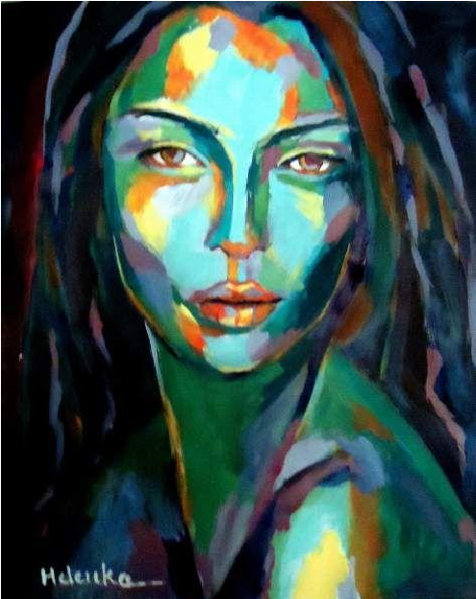

2. Still -life
Set up a still life with strong light source, near a window or with side light.
Possible objects: eggs on torn or crumpled paper, tin cans or glass jars, fruit on drapery, a
collection of brushes, a grouping of shoes, or raid the vegetable bin of the refrigerator. Be
sure to compose the entire page.
Still life drawing objectives:
• Strong lights and darks
• Side lighting (dramatic)
• Balanced grouping of objects
• At least 5 objects (You may have 3 but then you must utilize cropping and shadows)
• These pieces show how an effective use of side lighting can create a dramatic effect in an
otherwise mundane grouping of objects. Your drawing should have a full range of value
from light to dark in order to create a strong impact.
• for example, this artist has used interesting angles and considered the negative space around the objects and has cropped the composition so that the objects don’t float in space.
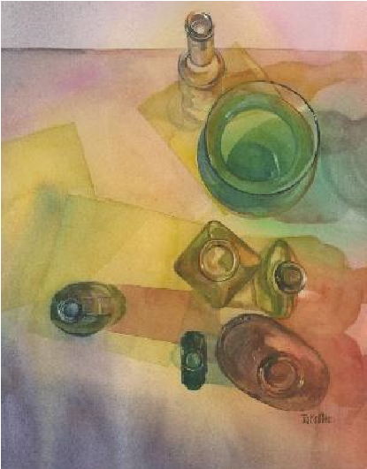

3.Reflections
Show reflections in a metallic object or other reflective surface: Zero in on a section of
reflective objects, such as a close-up of part of a bike or motorcycle, car bumper, spoons, an
eggbeater or other objects or surfaces that reflect their surroundings. Create a composition
making use of hard-edge reflections and cast shadows. Include other detail or background
that creates a good composition.
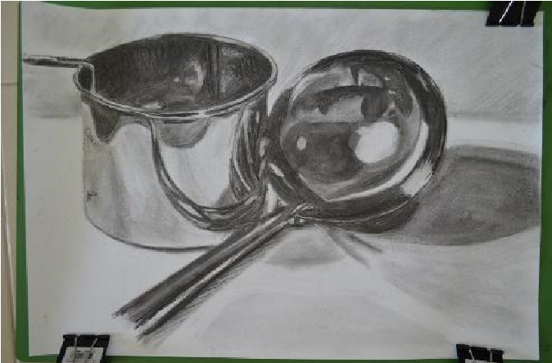

2D DESIGN ASSIGNMENTS (with a general emphasis-general emphasis may also do one project from the other 2D Design lists, photo and graphic design):

1.Nature Sketchbook
Get outside! Take your camera or sketchbook and do a series of NATURE CLOSE UP sketches.
Select one and render in pencil. Concentrate on values and textures. Make sure you have a
range of values from light to dark. Get very detailed on the texture. Add your own unique
style. You may use collage. Consider adding a splash of color in a different medium (ink,
watercolor, etc.) If using photography for this assignment, take at least 10 close up photos,
shoot in black and white if possible, make sure you have good lighting and a range of values.
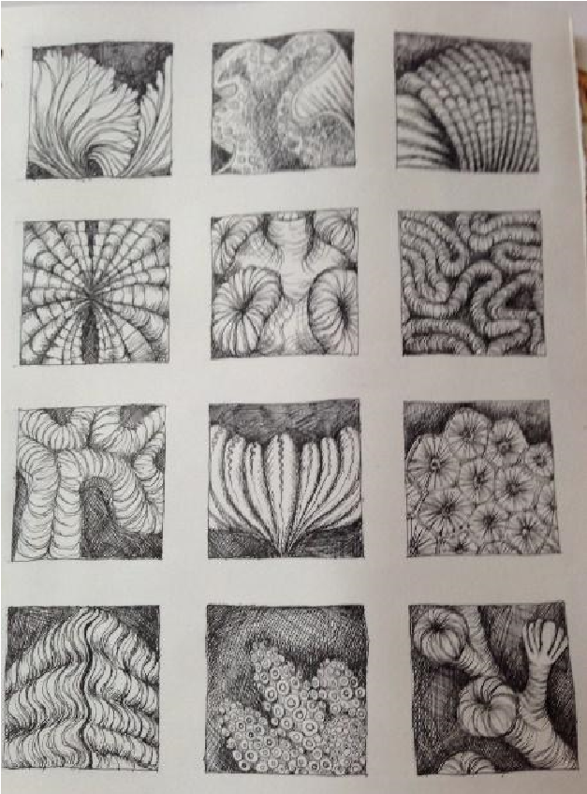

2. Abstraction
Research abstraction. Create an abstract work—faces, animals, objects, etc. Find an area of emphasis and make sure it stands out. Show foreground, middle ground and background. Make sure you use size variation and overlapping. Bring your own unique style to this project. You may use colored pencil/pastel, acrylic on canvas board or Photoshop/Illustrator for this assignment.
Project goal: try to formally show what an object is but not what it looks like. Abstraction removes the burden of realism and clarity.
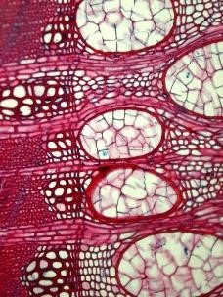

3. Five Chairs
Compile a grouping of 5 or more chairs- chairs can be all the same or a variety of colors,
styles, heights, and shapes. Chairs can intersect each other, overlap, or be transparent. This
can become a realistic or cubist piece. Try out different color relationships, for example:
make them complimentary, analogous, primary, or triadic. Concentrate on the negative
space. Shading okay but not necessary. Assignment may be a line drawing or use color.

Additional options for both portfolio types:

1.“There’s No Place Like Home​” – choose a very “Lived-In Room” to create an interior study. Use a​ viewfinder/camera to investigate your home, and create an artwork from a view of your actual home capturing a very "lived-in" moment - don't move anything, make the bed, or stage it. Show the life that was there, clutter and all. Concentrate on the variety of texture and values in the room.
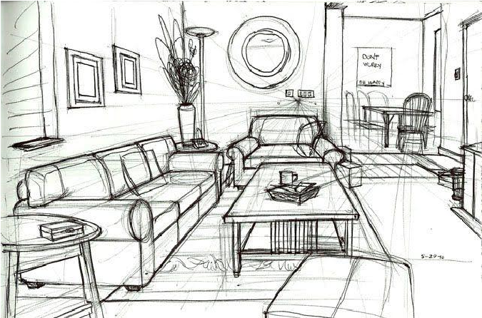

2.Be an ANT, be a GIANT (foreshortening) – Create artwork with a vantage point in mind. ​Subject is open but composition is the key. For this assignment, when getting reference, hold your camera at a very low point on the​ ground and take a photo of your subject from below (ANT). OR stand high above your subject and take a photo looking down. (GIANT)
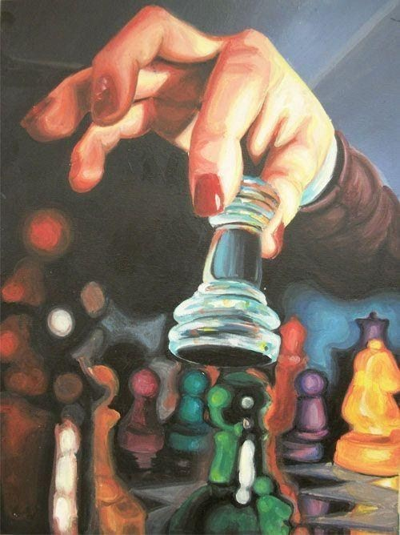

3.Inside Out” - An Interior's Interior ​ -​ Create artwork from an unusual interior space –
Hold your camera inside a closet, refrigerator, cabinet, car, phone booth, aquarium, dog crate, hamster cage, elevator, drawer, etc. try unique angles for an interesting composition.
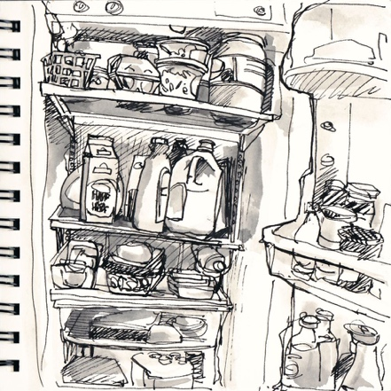

4.Gadgets -​ Zoom in on an interesting composition that minimizes the negative space with unique objects. Shells / Jewelry / Utensils / Marbles / Bicycle Chain / Instrument
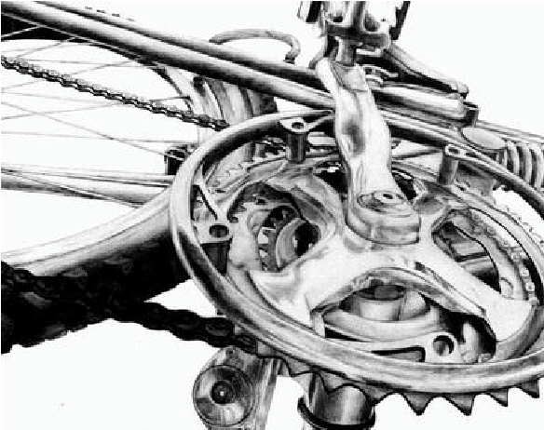

5. Piles/Clutter-​ Create an artwork from piles of shoes, toys, laundry, seashells, dishes, marbles, etc. Variety is import: color, texture, values, line weight, etc. Composition is equally important. Consider different angles before you start. Flat piles are not happy piles.
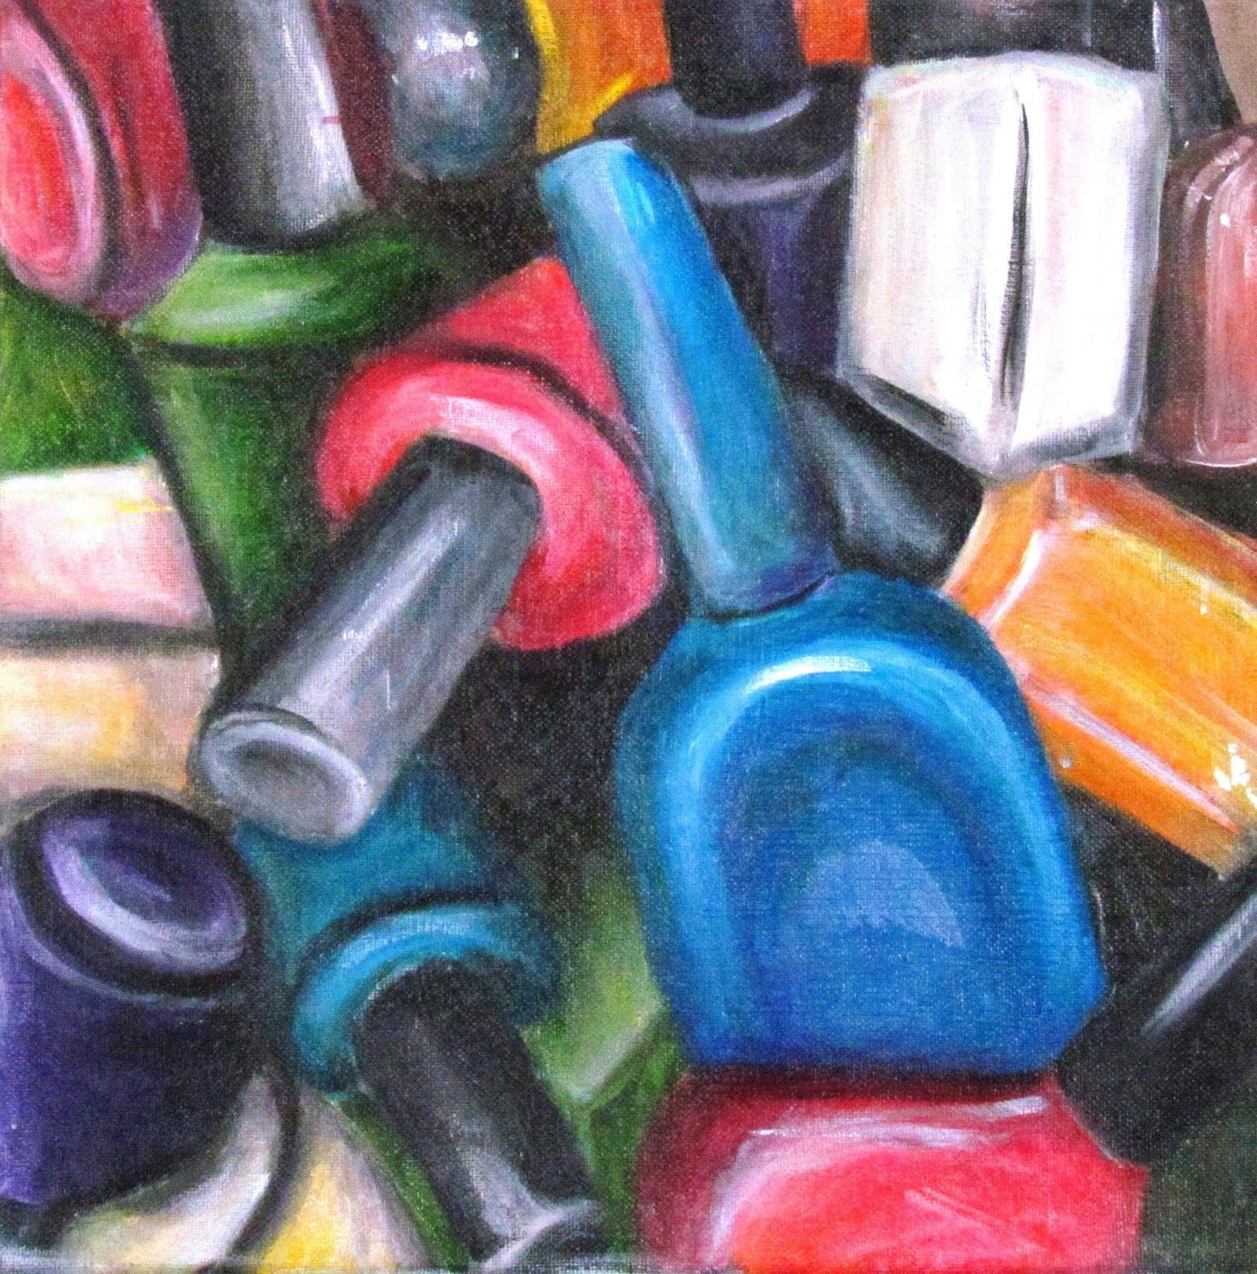

CONCENTRATION:

6. Anachronism- You will need to investigate what art looked like from a certain era- research clothing, color palettes, subjects and themes. Create a piece of art about your summer, but using very specific information that is not indicative of our current era. You might draw, for example, a Mucha advertisement taking an IG selfie photo in the advert.

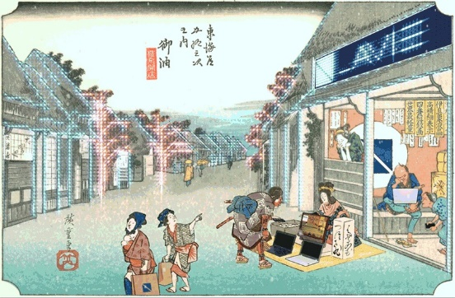

Lastly, you should be thinking about and developing your Sustained Investigation idea during the summer. Your concentration will be 15 pieces of related works of art, and will be the focus of the AP Studio Art class in the fall semester. You can access information about the concentration section of the AP Studio Art portfolio at the College Board website under the course description for AP Studio Art (2D design or drawing).

GETTING REGISTERED AT THE COLLEGE BOARD WEBSITE:
Just as soon as possible, register at www.collegeboard.com !!! Here you will find information about
AP Studio Art classes, the exam, scoring rubrics used, and examples of past student work in each of the portfolio areas.
• From the www.collegeboard.com homepage, click on the “For Students” tab
• Under “My organizer” you can create a free user account – you can use this account to access information about any AP exams and classes
• Under the “College Board Tests” section, you can click on “AP” which will take you to the AP homepage
• Here is a direct link to the AP subjects homepage, where you will find links to all of the AP
course descriptions: http://www.collegeboard.com/student/testing/ap/subjects.html
• Here is a link to the Studio Art homepage:
http://www.collegeboard.com/student/testing/ap/sub_studioart.html?studioart

Best to you this summer and PLEASE email me if you have any questions.
Desire breeds practice. Practice breeds comfort. Comfort breeds skill. Skill breeds more desire.
Jason Sobol
Jason.sobol@stjohns.k12.fl.u

