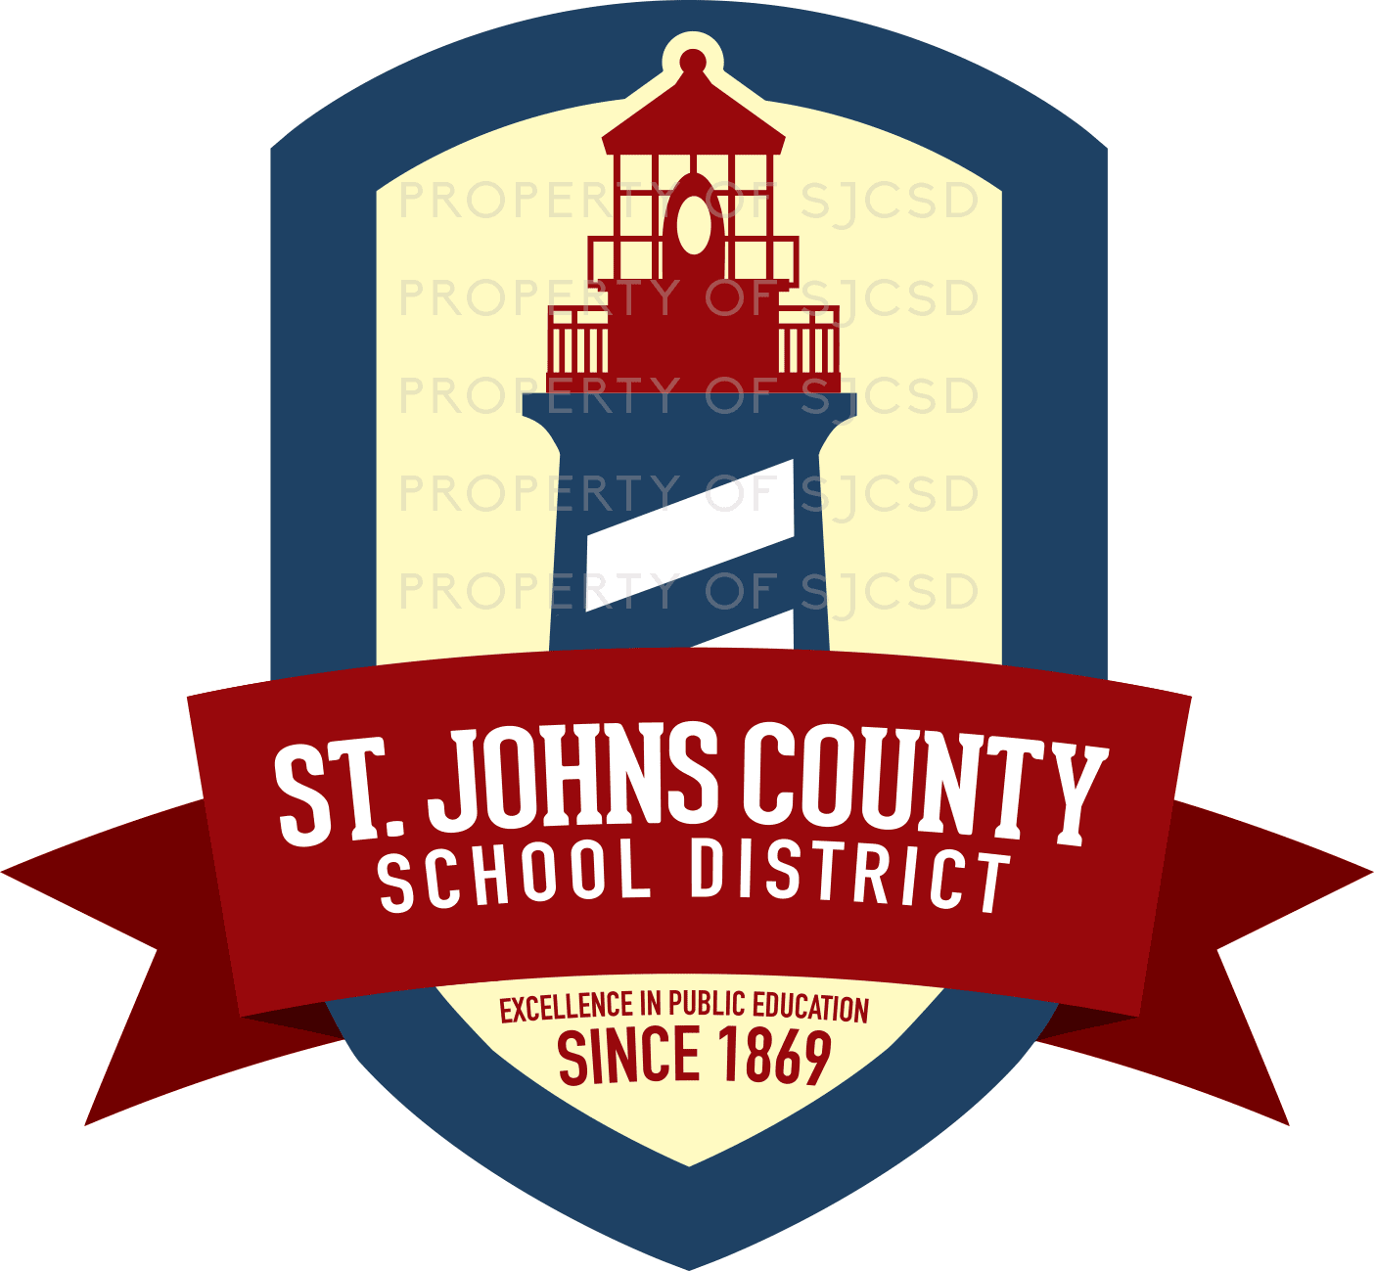
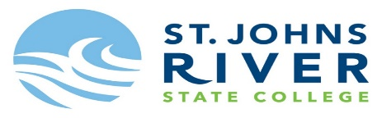

Collegiate High School
Tocoi Creek High School

The Collegiate High School Program offered in partnership with SJR State College is a Dual Enrolment Program that creates an opportunity for a cohort of eligible students to enroll in college level classes and earn their Associate in Arts degree, all while still enrolled in high school.
Current 8th and 9th grade students who have met the initial eligibility and their parent/guardians have been invited to an information session to hear more about this unique Dual Enrollment Program. The information session is a required component for all applicants because it will help students understand if this rigorous and comprehensive program is the right academic pathway for success.

Initial Eligibility

- Current 8th and 9th Grader
- Enrolled in Algebra 1 or higher
- 8th and 9th grade 1st Qtr. Report Card (No Ds or Fs)
- A level 3, 4 or 5 on the most current Florida Standards Assessment for English Language Arts and Math

Additionally, the student’s final 8th or 9th GPA is required to be a cumulative unweighted GPA 3.0 or higher.
It is recommended that students invited should demonstrate a strong performance in English, Reading, and Math courses and have the desire to participate in a rigorous academic program.

Students who meet the above criteria but did not receive an invitation should reach out to Lindsey Page, District Counselor, Middle & High Schools@ Lindsey.Page@stjohns.k12.fl.us, Gina Fonseca, Director for Secondary Instructional Services @ Gina.Fonseca@stjohns.k12.fl.us or visit
https://www.stjohns.k12.fl.us/guidance/collegiate-high-school/

