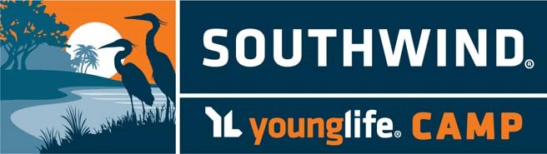

Southwind Younglife Camp Information:
18115 SE 95th St Rd
Ocklawaha, FL 32179
Phone: 352-288-2500

Departure Time: Friday, May 11th 4:30pm
Arrive Home: Sunday, May 13th around 10:00am

LINK CREW TRAINING AGENDA 2016
Friday
4:30 | Leave School
6:30-7:00 | Check In
7:00-7:45 | Dinner
7:45-8:15 | Southwind Challenge
8:30-9:00 | Whole Group (snowball fight)
9:00-10:00 | LINK CREW TRAINING (TRACK SCHEDULE)
10:00-11:00 | Dance off
11:00-11:30 | Cabin Time & Lights Out by 11:30
Saturday
7:30-8:00 | Whole Group
8:00-8:45 | Breakfast
9:00-10:00 | LINK CREW TRAINING (TRACK SCHEDULE)
10:00-11:00 | LINK CREW TRAINING (TRACK SCHEDULE)
11:00-12:00 | Free Time
12:00-1:00 | Lunch
1:00-3:00 | Free Time - Open Camp - Ropes Course
2:45-3:00 | Snack
3:00-4:00 | LINK CREW TRAINING (TRACK SCHEDULE)
4:00-4:30 | Whole Group (Go Big, Total Support)
4:30-6:00 | Talent Show Prep
6:00pm-7:00 | Dinner and campaign speeches
7:00-8:30 | “Link Crew Has Talent” Show
8:30-10:00 | Camp Fire Ceremony
11:00pm | Lights Out
Sunday
6:15- 7:00am | Pack up , Clean Cabins
7:00- 8:00 | Brunch
7:30-8:00 | Awards
8:00 | Load Buses and Head home
Link Crew Retreat
What to pack for the retreat…

Do not pack a huge suitcase. We are only going for two days!!
Bedding:
Set of twin sheets
Pillow
Pillow case
Warm blankets or sleeping bag
Mattress pad (optional)

Clothing:
Lightweight Jacket/ Sweatshirts
Ball cap/ Hat
Sweatshirt
T-Shirts
Shorts
Swimsuit
Under garments
Poncho or umbrella
Tennis Shoes
Water Shoes (optional)
Flip Flops for bath only

Bath Items:
Towels
Tooth Brush & Toothpaste
Hair Brush - comb
Toiletries
Hair Bands (must also be worn at Ropes Course)
Sunscreen
Insect repellent

Miscellaneous:
Pen/ Pencil
Skit script and props
Flashlight & batteries
Phone charger
Plastic bag for wet/ dry clothes
Water Bottle
Medications given to the nurse
Snacks

**Southwind is not responsible for misplaced or damaged items.**

