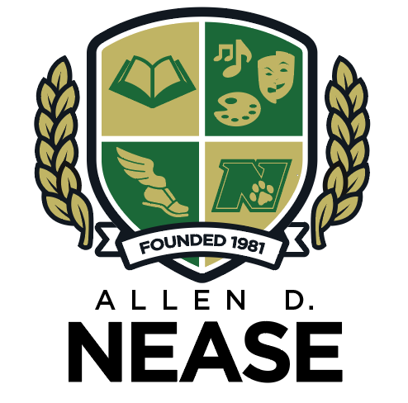

Nease High School
Semester 1 Exam Schedule
2018-2019
Tuesday, December 18, 2018
09:15-10:45 Period 1
10:45-10:55 break
10:55-12:25 Period 2
12:30-1:00 Lunch
1:00pm Buses depart

Wednesday, December 19, 2018
09:15-10:55 Period 3
10:55-11:05 break
11:05-12:45 Period 4
12:45-1:30 Lunch
1:30-2:45 Study hall & make up exams
2: 45pm Buses depart

Thursday, December 20, 2018
9:15-10:45 Period 5
10:45-10:55 break
10:55-12:25 Period 6
12:30-1:00 Lunch
1:00pm Buses depart

Friday, December 21, 2018
9:15-10:45 Period 7
10:50-11:20 Lunch
11:25am Buses depart
There is no facility to take exams early. Makeup exams will be given EACH DAY following the second exam or upon return from winter break on January7, 2019.

