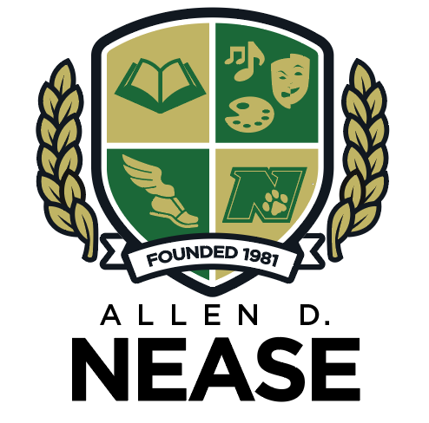

August 15, 2018
Dear Parents/Guardians:

The St. Johns County School District’s high schools will be administering the PSAT/NMSQT test on October 10, 2018. If you would like your 9th or 11th grade student to take the PSAT, there is a nominal fee of $20.00 charged by schools for the test to be graded. All checks should be made payable to Nease High School, with your student’s name and grade in the bottom left corner. Alternatively, if you would like to pay online, please return to the main page and use the school pay facility. A final payment option will be available during Open House on August 23, 2018. All students opting to take the test must submit payment by September 4, 2018.

Listed below are some reasons why your student should consider taking the PSAT/NMSQT:
- Grade 10 pre-college testing provides a basis to increase college participation.
- The PSAT is an indicator for performance on the SAT.
- PSAT includes verbal, mathematics, and writing components; it is used as a diagnostic tool to measure strengths and weaknesses for both students and curriculum.
- The PSAT helps assess academic skills necessary for college-level work.
- For students in grade 11 the PSAT/NMSQT is the National Merit Scholarship Qualifying Test. Students who meet the cut score are National Merit Semi-Finalists and can apply for Finalist status. National Merit Finalists in the State of Florida receive a full cost of attendance at any Florida State University.
Please sign your student up for the test and return the letter and payment to Mrs. Ashcroft in Room 226 Panther Hall or hand in to the school’s main office.

Sincerely,

Jacqueline Ashcroft
Allen D. Nease High School, Testing Coordinator

________________________________
Print Student Name

______________________________ ___________________________
Print Parent/Guardian Name Date

