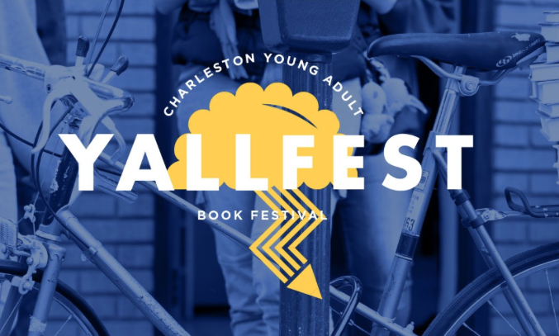
Yallfest Informational Meeting

Agenda

- What is Yallfest? The largest FREE young adult book festival in the U.S! Over 70 authors will be on hand to meet and greet young adults and autograph books. For LOTS more info go on this website: http://www.yallfest.org/schedule/

- Trip dates: Departure – Thursday, Nov. 9th / Return – Saturday, Nov. 11th (late)

- Ticketed events –
  - Keynote Opening – Patrick Ness (A Monster Calls) and Renee Ahdieh (A Flame in the Mist) - $10
  - Keynote Closing – Marissa Meyer (Lunar Chronicles) and Cassandra Clare (Lord of Shadows and Shadowhunters series) - $10
  - YA Smackdown – Saturday at 6 p.m. - $14 (I’m taking care of that for everyone!)

- Tour Company: Green Light Group Tours

- Cost – $305 (based on 50 students attending – will be slightly higher if less than 50 students sign up)
  - Included in trip package
    - Motor coach transportation
    - 2 nights lodging at the SpringHill Suites – 7353 N. Forest Drive, North Charleston, SC 29420
    - Breakfast daily at hotel
    - Nighttime hotel security

- Deposit - $100 due by Friday, Sept.8th. Must be a check made payable to Nease High school and include student’s full name and student ID number. The balance will be due online directly to Greenlight Tours via online link (will be emailed at a later date) FULL PAYMENT of balance will be due Monday, Sept. 25th.

- Online Registration – will need to be done through GreenLight Tours. More info to follow in the next week or so.

- Remind – sign up to my “Yallfest” Remind account so I can keep you updated! (on back of this shee)

