AP ENGLISH LANGUAGE AND COMPOSITION
for Pre IB English II students 2017 - 2018

SUMMER ASSIGNMENTS: (No assigned “Summer Reading”)
- Enjoy Your Summer!
- Purchase the following TWO BOOKS which we will use throughout the course next year. You will need them Day 1!
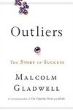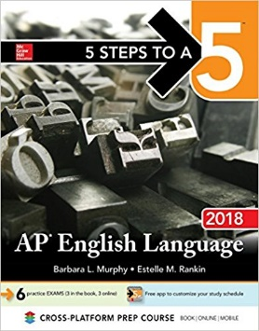
Malcolm Gladwell’s Outliers 5 Steps to a 5: AP English
ISBN 10: 0316017930 Language 2018
ISBN 13: 9780316017930 (Currently on Pre-Order)
ISBN-13: 978-1259862311
ISBN-10: 1259862313
- Watch, Read, and Listen to the news. Be aware of what is going on in the world – both locally (community, district, state, region) and nationally and internationally. Two of the AP English Language and Composition exam essays will allow you to use personal experiences (anecdotes) and current events in your writing.
- View and begin to study the AP English Language and Composition Terminology: https://quizlet.com/82306260/english-language-and-composition-flash-cards/We will work with this terminology throughout the year.

